PAWZAZZ  April 1&2 2023  Millersville, MD  At Hog Dog  Judge:  Jean Wilkins  Single Run Format  Building and Ring Surface info:  Sand Dirt  Contact Surface:  Rubber  Crating Set up times:  TBA  Briefing at:  7:30 each day  First dog on the line at:  7:45 | Preliminary Class Order:  May change depending on weather, judges preference, time or number of entries  Saturday  Class: Single Run  jumpers 1  regular 2  Touch & go 1  gamblers chances 1 1  Sunday  Class: Single Run  regular 2  chances 1  tunnelers 1  weavers jumpers 1 1  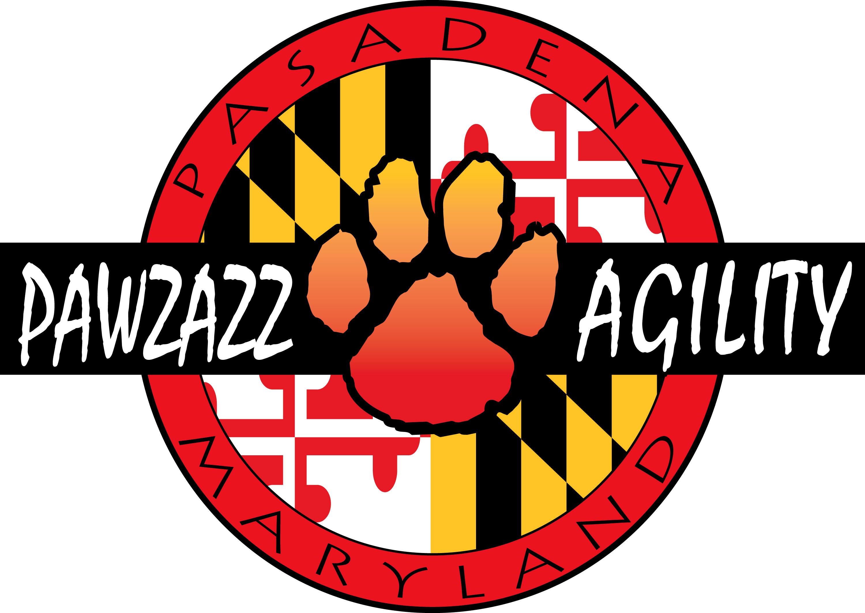

Entries Open on:  No opening date  Entries Close on:  Noon 3/22  Crating available:  indoors  .  Entry Limits:  400 runs per day  Move ups:  You must send in all changes by noon 3/27 We will do move ups at the trial from Sat to Sun  Day of show Entries:  May be possible contact us first.  Refunds:  No entry fee will be refunded if the trial cannot open or be completed by reasons of riots, civil disturbances, fire, an act of God, public emergency, an act of public enemy, or any other cause beyond the control of the organizing committee including weather or other acts of nature. The exception is cancellation because of COVID>> | Show Committee  Show Chair and Secretary:  Terry Wright  Tebi8399@gmail.com  Chief Course Builder :Tom Moloney Harmon  Equipment Manager Tia Stinnett  Confirmations:  You will receive a minimum of 2 confirmations. The early one will indicate receipt of entry and the last one will have all trial details.  Food info:  Not known yet but we may do pizza!  Volunteer info: Workers Needed! As always, we depend upon YOU and your fellow competitors to help run our trial. To make this easy, there will be a Worker Schedule posted at the trial site where you can sign up for the classes and jobs that YOU prefer to work! Remember, the Worker Schedule must be filled out and workers assigned before each class can begin. Thank you in advance for the generous contribution of your time and energy.  Awards and Ribbons:  Ribbons for all placements and rosettes for awards  Equipment info:  Rubberized contacts, 24” weaves and electronic timers
Jump Height Info:
MEASURING
Measurement forms may be obtained ahttps://www.nadac.com/WPsite/wp-content/uploads/2021/06/Permanent-Height-Card-form-6.4.21.pdf
Dogs which require measuring:
Dogs in the Proficient Category, Novice, Open or Elite jumping 4”, 8”, 12” or 16”

Dogs which do not need to be measured:
Dogs jumping 16” in the Veteran or Junior Handler Division
Dogs jumping 20”
Dogs in the Skilled Category
Dogs with a permanent height card
Dogs listed on the Height Exemption List
JUMP HEIGHTS
There are four Standard Division-Proficient jump heights: 8”, 12”, 16”, and 20”.
There are four Standard Division-Skilled jump heights: 4”, 8”, 12”, and 16”.
There are four jump heights for the Veterans and Junior Handler divisions: 4”, 8”, 12”, and 16”.
Please see the NADAC Rulebook for the full jump height table

Brief Summary of Rules:
Please refer to www.nadac.com for a full explanation of all NADAC rules and up to date information.

- Please note that NADAC trials should provide a safe and fun environment for both exhibitors and their dogs.
- Aggressive dogs will not be tolerated and will be excused from the trial.
- The show committee has the right to refuse any entry. Anyone not currently in good standing with NADAC will not be allowed to enter this trial.
- Exhibitors, through submission of entry, acknowledge that they are knowledgeable of NADAC rules and regulations, and agree to abide by all rules in effect at the time of this trial.
- No entry fee will be refunded if the trial cannot open or be completed by reasons of riots, civil disturbances, fire, acts of God, public emergency, an act of a public enemy, or any other cause beyond the control of the organizing committee.
- Checks not honored by the bank do not constitute a valid entry fee. There will be a $25.00 service charge for bank returned checks.
- Dog must be registered and have a valid registration number before entries will be accepted https://www.nadac.com/register-your-dog/
- A copy of the current Exhibitors Handbook may be downloaded free from the NADAC web site: www.nadac.com
- Bitches in heat, lame, or blind dogs are ineligible for entry, as is any dog with a deformity which may cause a judge to not be able to reasonably assess the dog’s ability to function and perform agility obstacles safely, and in a manner that is in the best interest, health and welfare of the dog.
- No food, clickers, or other aids or devices shall be permitted on the course or within 10 feet of the ring. Food or a small non-audible toy can be in a secure container (ziplock bag is acceptable) in your pocket during your run but you cannot indicate to the dog it is there. All handlers may bring a non-audible toy into the ring for training purposes. They cannot earn a Qualifying score and must declare to the judge they are training before they commence their run. Please read the Exhibitor’s Handbook for more information about toys and training in the ring.
- The sponsoring clubs will not be responsible for the loss or damage to any dog exhibited, or for the possessions of any exhibitor whether the result be accident or other cause. It is distinctly understood that every dog at this event is in the care and control of his owner or handler during the entire time the dog is on the show premises.

PAWZAZZ Agility Trial, 4/1&2 2023 Millersville, MD Make Checks Payable to: Kinder-Pup, Inc.
Send entries to: Kinder-Pup, Inc., 712 Dorol Ct, Severn, MD 21144
Owner |  |  |  | Dog
Name |  |  |  | Call Name
Address |  |  |  | NADAC Reg #
City/State/Zip |  |  |  | Date of Birth
Phone |  |  |  | Height at Withers
Email |  |  |  | Breed
Handler, If not owner |  |  |  | Emergency Contact Name/Phone
PLEASE INCLUDE A COPY OF YOUR DOG’S HEIGHT CARD IF YOU DO NOT HAVE ONE ON FILE.
CATEGORY: PROFICIENT SKILLED
DIVISION: STANDARD VET DOG VET HANDLER JUNIOR HANDLER
I WANT MY DOG TO JUMP: 4 8 12 16 20
Class | Level |  |  | Day
 | Novice | Open | Elite | Saturday | Sunday
Regular |  |  |  | Rd 1 Rd 2 | Rd 1 Rd 2
Chances
Jumpers
Touch n Go
Tunnelers
Weavers
Gamblers
In consideration of the acceptance of this entry, I/we certify that I/we have knowledge of, and are familiar with, and agree to abide by, the Rules and Regulations of NADAC in effect at the time of this trial, and by any additional rules and regulations as approved by NADAC for this trial. I/we certify that the dog entered is not a hazard to persons or other dogs. I/we further agree to be bound by the “Agreement” printed on page 5 of this premium

Number of Total Runs Entered (all dogs): # ___________
□ 1-4 runs $14each = ___________
□ 5-24 runs $13 each = ___________
□ 25 or more runs $12 each = ___________
□ Junior Handler $26 per day per dog = ___________
□ Entries received after closing date 3/22 $15 each = ___________
___________
□ Return check fee $35
TOTAL ENCLOSED = ___________
My Dog’s song is:
Owner/Exhibitor: ____________________________________Date_______________________
Parent or Legal Guardian of Junior Handler: _________________________________________
AGREEMENT
The person who signs this agreement represents that he/she is authorized to enter into this agreement on behalf of both exhibitor and the owner of entered dog. In consideration of acceptance of this entry:
1.1 As used here 'NADAC' means North American Dog Agility Council, Inc., its members, officers, directors, employees, show chairs, show committees and agents.
1.2 Exhibitor/owner agree to abide by the rules and regulations of NADAC, and any other rules and regulations appearing in the premium for this event.
1.3 Exhibitor/owner certify that the entered dog is not a hazard to persons, dogs, or property, has never been dismissed, excused or prohibited from entering any dog training class or event of any kind and that the entered dog's rabies vaccination is current in accordance with the requirement of the state in which the dog resides.
1.4 Exhibitor/owner acknowledge all hazards presented by the event and the event premises, including, but not limited to, the condition of the floors, stairways, halls, lighting, security measures or lack of, electrical appliances, fitting, show rings, parking areas and the presence of unfamiliar animals and people; exhibitor and owner assume the risk of any harm arising from these.
1.5 Exhibitor/owner release NADAC LLC (including NADAC officers, directors, employees, and members), KINDER-PUP, INC and TEAM PAWZAZZ (including its officers, directors, and members, and event organizing committee), HogDog LLC (including its officers, agents, and employees) and will defend them and hold them harmless from all present and future loss, injury, damage, claims, demands and liabilities involving the entered dog, the event or event premises. Without limiting the generality of the foregoing hold harmless provisions, exhibitor/owner hereby specifically assume sole responsibility for and agree to indemnify and save aforementioned parties harmless from any and all loss and expenses (including legal fees) by reason of the liability imposed by law upon any of the aforementioned parties for damages because of bodily injuries, including death, at any time in consequence of my (our) participation in this event, howsoever such injury, or death may be caused, and whether or not the same may have been caused or may be alleged to have been caused by negligence of the aforementioned parties or any of their employees or agents or any other persons.
1.6 Exhibitor understands there is a returned check fee of $35.
In consideration of the acceptance of the entry, I/we agree to abide by the rules and Regulations of NADAC in effect at the time of this trial, and by any additional rules and regulations as approved by the board of NADAC for this trial. I/We certify that the dog entered is not a hazard to persons or to other dogs. I/We further agree to be bound by the “Agreement” printed above.

Lodging Info and Directions:
The following will accept well-mannered dogs. Please double check when making reservations. HOTELS: (All are between 10 and 13 miles/15-20 minutes from the trial site)
Aloft Arundel Mills, 7520 Teague Road, Hanover MD 443-577-0077
Comfort Inn Airport, 6921 B&A Blvd., Linthicum, MD 410-789-9100
Holiday Inn Airport, 6921 Elkridge Landing Road, Linthicum, MD 410-859-8400
Red Roof Inn Airport, 827 Elkridge Landing Road, Linthicum, MD 410-850-7600
KOA 410-923-2771
RV Camping is allowed at this trial. There are 2 30-amp hookups and 1 20-amp hookup available. Dry camping and tent camping are also allowed. Electric spots are $25 a night. Dry camping is $15 a night. Tent camping is $10 a night. There are showers available in the restrooms. You may not arrive before 3:30 PM the night before the show starts. To reserve a spot, you must pre-pay. Please contact Lee Carr at fluple@hotmail.com. Include the size of your RV, number of slides and length.
Directions to Facility: DIRECTIONS TO FACILITY: 470 Ski Lane, Millersville, Maryland, 21108 From the North: Take I-97 South off the Baltimore
Beltway. Exit New Cut Road. Turn right at the end of the ramp. Follow approximately1.5 mile to fork in road. Bear left onto
Gambrills Rd. Go approx 2 miles to flashing red traffic light and turn left onto Dicus Mill Rd. Turn right at the second street,
Ski Lane. After 3 houses, the main road turns left and the driveway to 470 continues straight ahead. Follow the signs to
the far back of the property.
From the South: Take either I-97 North or Rte 3 north to Rte 32 west. Exit Burns Crossing Road. At the end of a long ramp;
turn right at the traffic light onto Burns Crossing. Take the first immediate street on the right, Dicus Mill. Go approx two
miles to stop sign and flashing yellow light, continue straight and follow the directions above to Ski Lane.
From the West: Take Rte 32 east to Burns Crossing Road. Turn right at end of ramp. Right at first traffic light, then left at
next light onto Burns Crossing. Turn right onto first immediate street, Dicus Mill and follow directions above.

Club Policies
- All dogs must be on leash in the building when not competing in the ring.
- No entry fee will be refunded if the trial cannot open or be completed by reasons of riots, civil disturbances, fire an act of God, public emergency, an act of public enemy, or any other cause beyond the control of the organizing committee including weather or other acts of nature. The exception is cancellation because of COVID.
- Checks not honored by the bank do not constitute a valid entry fee. There will be a $35 service charge for bank returned checks.
- Running order is determined alphabetically. Handlers with more than one dog in a class will be separated if possible.
- All dogs for a given class should be present at ring side at least one-half hour prior to the start of the scheduled classes for walk through and briefing. Any dog and handler not present when they are called will be ineligible to run.
- No alcoholic beverages are allowed on the show site.
- There will be no refunds for entries in the event a dog and/or handler are dismissed from competition regardless of the reason for such dismissal.
- A withdrawal from the competition after the closing date due a bitch coming into season after the closing date will be eligible for a credit of 50% of the total entry fee paid to be used within 6 months at a future PAWZAZZ trial. A veterinarian's notice will be required for a credit. No other refunds will be given after closing date.
- Ribbons will be awarded to first through fourth places in all jump heights in all classes and for qualifying. There are title ribbons and award rosettes!
- Note: there are no placement ribbons awarded for Chances as it is a pass/fail class.
- It is expected that owners of dogs who are extremely noisy or protective of their spaces will tent/crate away from high traffic areas and areas near the ring itself.
- No dogs may be chained or tethered at this trial. Please use crates, ex-pens or other suitable containment measures.
- If you smoke, please do not leave cigarette butts on the grounds. Smoking and vaping must be outside.
- If you enclose a copy of your height card with your entry, you do not need to do check in at this trial. No dogs entered in skilled need to be measured. 20” dogs and vets from those heights do not need to be measured. 20” dogs jumping 16" in the Veteran or Jr. Handler Divisions do not need to be measured.

